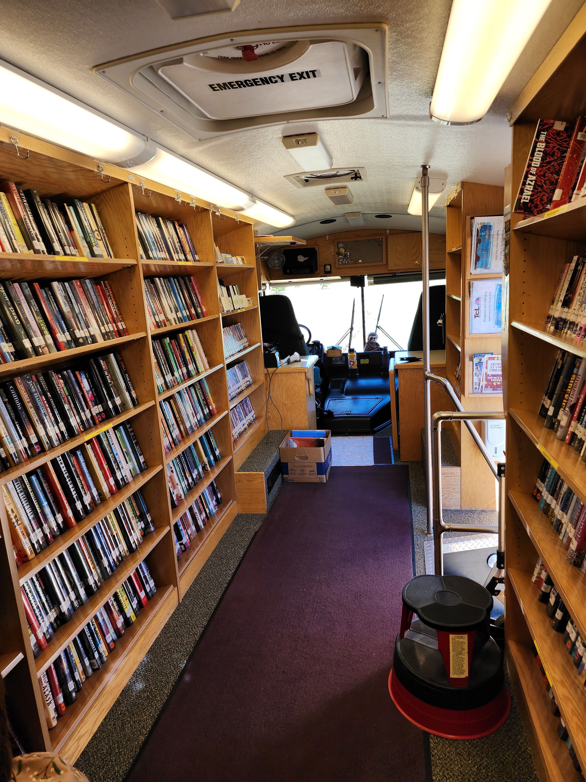  A peek inside the Bookmobile.  “Books… Expand your world!”  Schedule Subject to Change  Times listed in the schedule are approximate and delays may occur due to weather and traffic conditions. In the event of inclement weather, maintenance issues, or other emergencies, the Bookmobile may not be able to complete its scheduled run. For information call (503) 842-4792, check the library website @ www.tillabook.org, or check social media.  Facebook: www.facebook.com/TillamookCountyLibrary  Instagram: www.instagram.com/tillamookcountylibrary/ | In the Bookmobile You Can:  -Get a Library Card  -Check Out & Return Materials  -Pick-up Requested Materials  -Browse On-Board Collection of  - Novels - Non-fiction - Art Books - Gardening - Cookbooks - Large Print - Sci-Fi - Fantasy - Teen Novels - Picture books - Kids Chapter books - Manga - Graphic Novels - DVDs & CDs - Audio books  - Spanish Materials for All Ages  -Get Tech Help  -Participate in Storytimes & Crafts  -Get eBook & Digital Services Help  -Make Notary Public Appointment  Contact Us  Phone: (503) 842-4792 ext. 1710 Email: outreach@tillabook.org  Web: www.tillabook.org  tillamook county library bookmobile  1716 3rd St  Tillamook OR 97141 | tillamook county library bookmobile  - September 2025 through  - May 2026  - Schedule
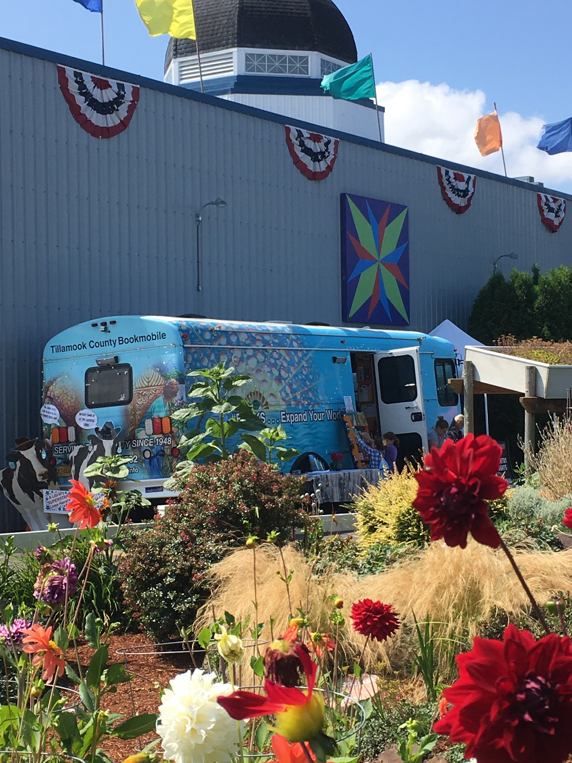  The Bookmobile at the County Fair.  Community Stops  The Bookmobile acts as a traveling branch of the TCL system. Stops are open to all patrons for library services. All materials are checked out with a return date of 4 weeks, or the next scheduled Bookmobile visit to your area. If you ask for specific items, they'll be held for you until the Bookmobile returns, even if you get a notice saying your hold is ready for pickup before then.  All Bookmobile town stops offer access to library materials and services as well as a simple craft, and a short storytime, and access to program materials.  “Books- The Portable Adventure” | Community Stops Schedule  - Ocean Highlands Community  1st & 3rd Monday 3:15-4:15 pm  1550 Ocean Highland Pkwy, Netarts  - Three Rivers RV Park  2nd & 4th Tuesday 2:30-4:30pm  31255 Hwy 101 S., Hebo  - Trask River RV Park  1st & 3rd Wednesday 3:15-4:30 pm  3370 Gienger Rd., Tillamook  - Laurelwood Mobile Home PK  2nd & 4th Wednesday 3:15-4:15 pm  3315 3rd St., Tillamook  - Neskowin Wayside Park  1st & 3rd Thursday 12:30-1:30 pm  48880 Hwy 101 S., Neskowin  - Nestucca River Village  1st & 3rd Thursday 3:15-4:00pm  24610 Hwy 101 S., Beaver  - Champion Park Apartments  2nd & 4th Thursday 3:15-4:15 pm  4317 Brookfield Ave., Tillamook  - Golden Eagle Apartments  1st & 3rd Friday 3:15-4:15 pm  804 Chestnut Dr., Tillamook  - Holden Apartments  2nd & 4th Friday 1:45-3:00 pm  3200 12th St., Tillamook  Holiday Closures:  - September 1st Labor Day  - November 11th Veteran’s Day  - November 27th & 28th Thanksgiving  - December 24th, 25th , 26th Christmas  - January 1st New Years Day  - January 19th MLK Day  - February 16th Presidents Day  - May 25th Memorial Day  Hours and closures are subject to change due to unforeseen circumstances. | 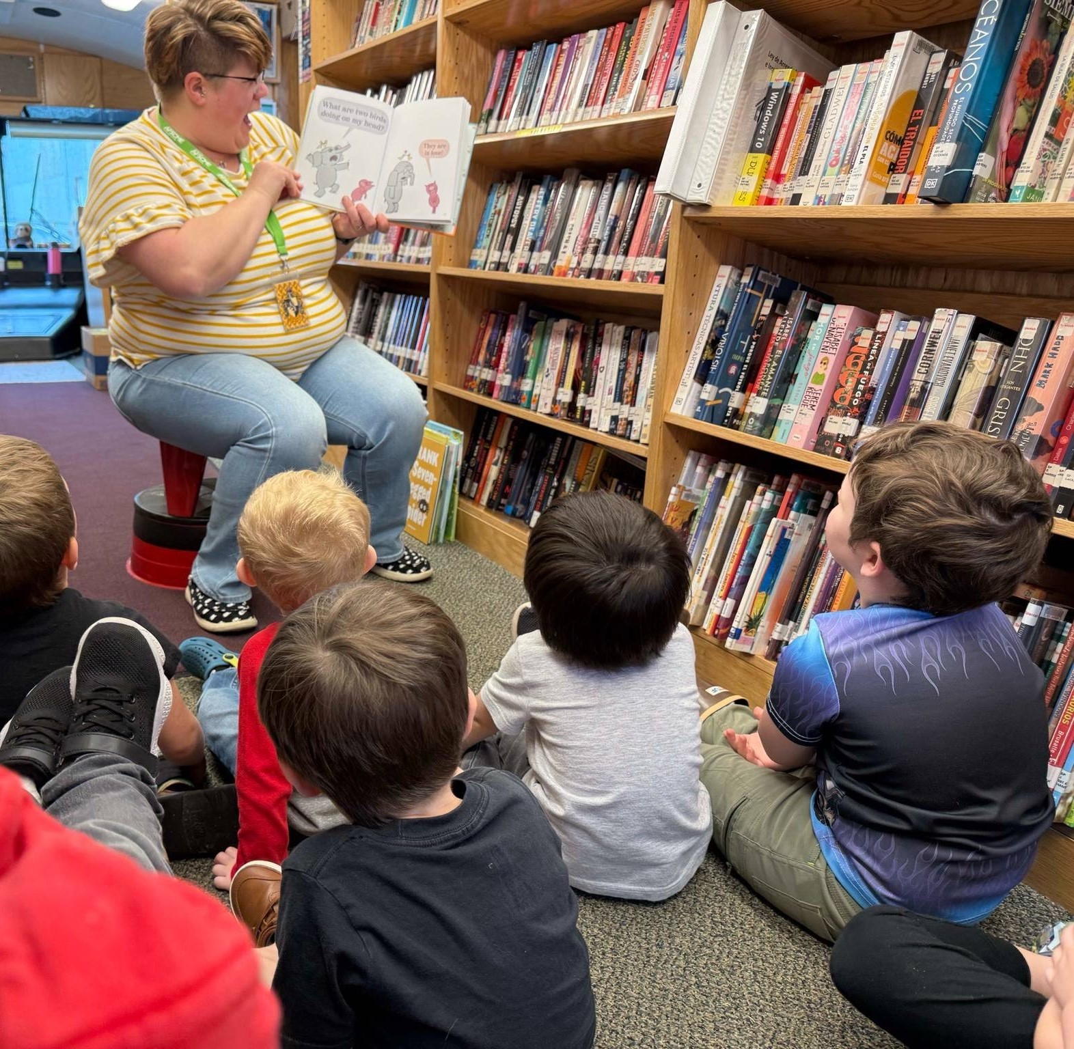  Storytimes are offered in The Bookmobile at many schools in the community.  The bookmobile travels to 20 schools and different community events throughout the school year, whenever it's not parked at its usual stops in the community.  Why So Many Schools?  The Bookmobile plays an important role in fostering a love of reading in the county. During these visits students get an age-appropriate storytime and an opportunity to check out books for the classroom, which encourages classroom learning and engagement.  Serving Tillamook County since 1948

